**Testimonies discrimination**

RACISM

Guillermo Akapo Bisoko

Guillermo is 29 years old, is originally from Equatorial Guinea, and he is an administrative clerk in a company in Madrid. However, he relates that he is discriminated by cops on the streets, they always stop him because of his skin color. Even if he has been in Spain for 20 years, has all his papers in order, and works every day in a company, he always ends arrested and showing his documentation to some policemen. He says that is impossible for him to feel integrated. He explains that when he arrived to Spain, he thought that all those “racist raids or stops” were normal and were routine arrests for any citizen, but after a while he realized that they stopped him because of his color skin. He feels uncomfortable because being surrounded by cops on the street for 15 or 20 minutes makes people think he´s a criminal. That’s when he found out he was a victim of the thought that being dark-skinned or immigrant meant being a criminal.

**Images of discrimination by the physic aspect**

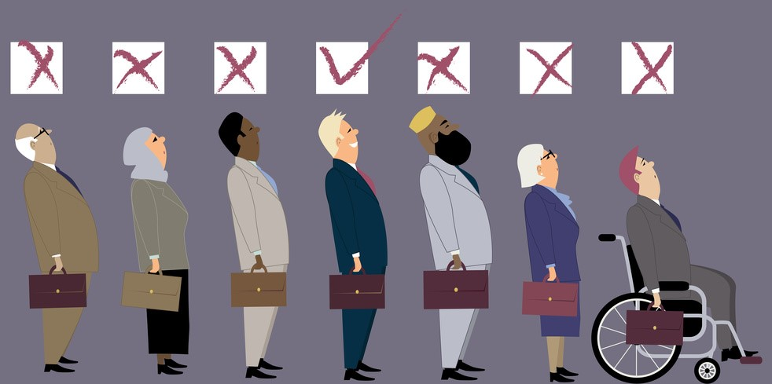



**Definition**

Treating, or proposing to treat, someone unfavorably because of a personal characteristic or feature, either complexion, skin tone, way of dressing, etc.